**Tab 1**

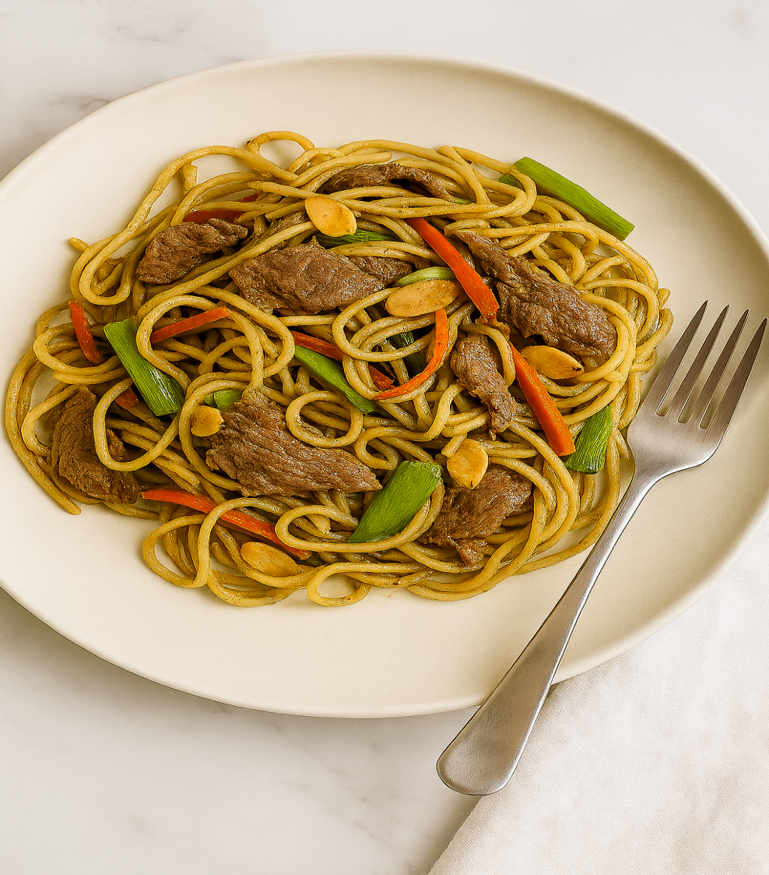

**NOURISH AND FLOURISH**

**Wholesome recipes to support life**

**With diabetes, one bite at a time.**

**Dani Ashby**

**About this book**

This book was born out of personal experience and deep loss. After losing close family members to diabetes, I felt compelled to understand the condition more fully. Though I’m not a medical professional, I’ve spent years researching diabetes—taking courses, speaking with health experts, and engaging with colleagues, friends, and

online diabetic communities. That journey led me to study nutrition, eventually qualifying as a Nutrition, Health, and Lifestyle Coach.

Following my loved one’s passing, I made a conscious decision to take charge of my own health. Years of dieting had left me with unwanted side effects and recurring illness, so I began exploring alternative paths— seeking a sustainable, nourishing lifestyle that didn’t rely on restrictive diets. Through trial and error, I retrained my habits and found balance by embracing a diabetic-friendly approach: cutting out sugar, reducing carbs, and choosing whole, healing foods. Though I’m not diabetic myself, I chose to live as though I were—because with diabetes in my family, I refuse to be next. And truthfully, I’ve grown to love the foods I eat.

Diabetes doesn’t mean a life without sweetness — it means choosing wisely. Natural sweeteners like stevia or erythritol can be helpful, and fruit (especially berries) offers fibre and antioxidants with a gentler glucose impact.

A balanced diet is key to supporting blood sugar control, maintaining a healthy weight, and reducing the risk of complications. But there’s no universal “diabetic diet” — everyone’s nutritional needs are different. That’s why the recipes in this eCookbook are crafted to be flexible: full of flavour, nutritionally thoughtful, and easy to adapt. Feel free to swap ingredients or tailor portions to suit your personal health goals. This book is a guide, not a rulebook — use it in a way that works best for you.

The recipes are also realistic, quick, and simple—perfect for busy lives. Many can be prepared in advance, offering a few days or even a week’s worth of nourishing meals. Each recipe takes no more than 30 minutes to cook.

I encourage you to build a meal plan that supports your lifestyle and helps you manage diabetes with confidence and ease.

**Tips for success**

Use herbs and spices to elevate flavour without added sugar or salt.

• Roast, steam, or grill instead of frying.

• Include colourful vegetables in every meal.

• Batch-cook balanced meals to reduce reliance on processed options.

Meal Prepping

Whether you prefer to prep during the week or set aside time on the weekend, meal planning can be a powerful tool for diabetic wellness. Consider batch-cooking versatile ingredients that can be used across multiple meals — grains, roasted vegetables, lean proteins, or soups. Making this a regular rhythm reduces the daily pressure of cooking and helps you stay aligned with your nutritional

goals. It also lessens the temptation to reach for convenience foods that may not support your blood sugar balance.

Storing Your Cooked Meals

Label each container with its contents and date, and store meals in clear, portion-sized servings for easy access. This not only saves time but also supports mindful eating. A well-stocked pantry with diabetic-friendly staples — such as herbs, spices, canned legumes, and frozen vegetables — can make the process smoother and more sustainable. Storing your cooked meals

Label containers with the contents and date, store meals in clear, portion-sized servings for easy access. A well-stocked pantry with diabetic-friendly staples, such as spices, canned goods, and frozen vegetables, can streamline the process even further.

Shopping

Build your weekly shopping list around your meal plan. Focus on low-carb choices, high-fibre foods, and snacks that support steady energy. Prioritise whole foods like fresh vegetables, lean proteins, and healthy fats — these provide essential nutrients while helping to maintain stable blood sugar levels. Thoughtful shopping is a form of self-care, and it sets the tone for the week ahead.

Snacks

Having witnessed diabetic episodes firsthand, I understand the importance of having nourishing snacks readily available. Portable options like nuts, seeds, or veggie sticks in small containers or resealable bags can make it easier to choose wisely when you're on the go. These high-fibre snacks support blood sugar regulation without compromising on flavour or convenience.

While snacks are a vital part of diabetic care, I’ve chosen not to include specific snack recipes in this book, as preferences and tolerances vary widely. I encourage you to explore what works best for your body and lifestyle.

## Quick Disclaimer

This resource blends practical nutrition, budget-friendly tips, and gentle faith-based encouragement. It’s shared from personal experience not as medical advice. Please consult a healthcare professional before making dietary or wellness changes. Use what blesses you. Modify what doesn’t.

All rights reserved.

* **TURMERIC POACHED EGG**
* **OMELETTE WITH COTTAGE CHEESE & BASIL**
* **AVOCADO & EGG PASTE**
* **SMOKED MACKEREL & EGG PASTE**
* **EGG BROCCOLI & HAM MUFFINS**
* **EGG, BACON & AVOCADO BOWL**
* **ZUCCHINI (Courgette) TORTILLA**
* **OMELETTE WRAPS**
* **COTTAGE CHEESE PANCAKES**
* **SMOOTHIE BOWL**
* **VANILLA & COFFEE SMOOTHIE**
* **BLUEBERRY SMOOTHIE**
* **CINNAMON SMOOTHIE**
* **TUNA & BROCCOLI SALAD VINAIGRETTE**
* **WALDORF CHICKEN SALAD**
* **TUNA & QUINOA SALAD**
* **SALMON & COUSCOUS SALAD**
* **COD & BULGUR SALAD**
* **CUCUMBER, AVOCADO & CHICKEN SALAD**
* **SMOKED SALMON & STRAWBERRY SALAD**
* **PEAR, CURED HAM & WALNUT SALAD**
* **CUCUMBER SALAD WITH SALMON**
* **HEALTHY CORONATION CHICKEN SALAD**
* **VEGETABLE SALAD WITH TUNA**
* **TURKEY SALAD**
* **BAKED LEMON CHICKEN SALAD**
* **WARM SALMON & QUINOA SALAD**
* **SESAME & GINGER BEEF NOODLES**
* **BAKED SALMON WITH NOODLES & QUINOA**
* **CHICKEN FAJITAS**
* **BEEF & GREEN BEANS PASTA IN SOY SAUCE**
* **SALMON TERIYAKI WITH GREEN BEANS & SWEETCORN RICE PESTO PASTA WITH TUNA & ALMONDS**
* **QUICK BEEF CHOW MEIN**
* **CHILLI & SWEET POTATO CHIPS**
* **CHERRY SORBET**
* **2 WAYS FRUIT BOWLS**
* **MATCHA CHIA PUDDING**
* **LOW FAT BANANA & STRAWBERRY CAKE**

**LIGHT MEALS**

There are moments when the body asks for less — not out of lack, but out of wisdom. A light meal can be a quiet offering: a way to honour hunger without overwhelm, to nourish gently, and to pause with intention.

This section is for those in-between spaces — midday resets, gentle suppers, or times when energy feels tender. Each recipe here is created to support blood sugar balance.

**TURMERIC POACHED EGG**

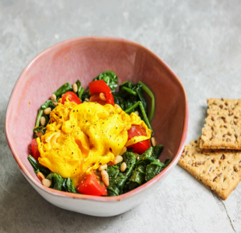

*Serves: 2*

*Prep: 10 mins*

*Cook: 5 mins*

2 tsp. pine nuts

1 ¾ cups (400g) of fresh spinach

⅝ cup (125g) of tomatoes, halved

1 tbsp. mild olive oil

1 tbsp. white wine vinegar

1 tsp. ground turmeric

2 medium-sized eggs

*Heat a dry frying pan and toast the pine nuts for 2 minutes, then set aside.*

*In the meantime, heat the oil in a frying pan and stir fry the spinach and tomatoes for 2 minutes on medium heat until wilted. Season with salt and pepper.*

*Bring a pot of water to the boil and add in the vinegar and turmeric. Turn the heat down so that the water no longer bubbles. Carefully break in the egg and poach for 3 minutes repeat with the second egg.*

*Divide the spinach over two bowls, top with the poached egg and sprinkle with toasted pine nuts. Season with salt and pepper. Break open the eggs just before serving.*

*Nutrition per serving:*

*219 kcal*

*15g Fats*

*12g Carbs*

*14g Protein*

**OMELETTE WITH COTTAGE CHEESE & BASIL** 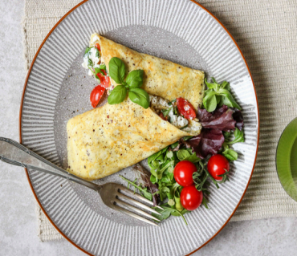

*Serves: 4*

*Prep: 10 mins*

*Cook: 10 mins*

6 large eggs

4 tbsp. water

1 tbsp. oil or butter

1 bunch fresh basil

⅞ cup (200g) cottage cheese

12 cherry tomatoes

*Beat the eggs with the water and season with salt and pepper.*

*Heat ¼ oil in a frying pan and bake 1 thin omelette, repeat until you have 4 omelettes. Keep them warm under aluminium foil.*

*Chop the basil finely and mix with the cottage cheese. Season with freshly ground pepper.*

*Cut the tomatoes into quarters. Divide the cottage cheese and tomato over the omelettes and roll them up. Cut diagonally and serve immediately.*

*Nutrition per serving:*

*200 kcal*

*14g Fats*

*3g Carbs*

*15g Protein*

**EGG BROCCOLI & HAM MUFFINS**

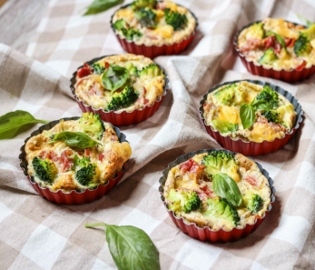

*Makes: 6*

*Prep: 5 mins*

*Cook: 15 mins*

½ broccoli

5 eggs

1 clove garlic, minced

pinch of chili flakes, optional

4 slices ham, chopped

⅓ cup (30g) grated cheese

*Preheat the oven to 360°F (180°C).*

*Place the broccoli in a pot of boiling water and cook for approx. 3 minutes. Strain and cut into small pieces.*

*Beat the eggs in a medium size bowl, add the minced garlic and season with salt and pepper, and chili flakes if using.*

*Grease a 6-mould muffin tray with oil or butter, and fill the moulds with evenly divided broccoli, ham, and grated cheese. Pour the beaten eggs into the moulds and bake in the oven for 10-15 minutes, or until eggs have set.*

***Vegetarian option:*** *replace the ham with feta cheese, Goats cheese or*

*your favourite vegetables.*

*Nutrition per serving:*

*102 kcal*

*6g Fats*

*4g Carbs*

*10g Protein*

**EGG, BACON & AVOCADO**

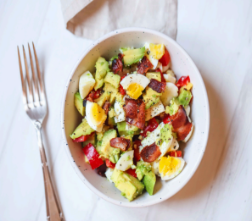

*Serves: 1*

*Prep: 5 mins*

*Cook: 5 mins*

2 bacon medallions

2 hardboiled eggs, chopped

½ large avocado, chopped

1 tbsp. red onion, finely chopped

1 tbsp. red bell pepper, finely chopped

sea salt and ground pepper, to taste

*Fry the bacon until crisp on a non-stick pan. Let it cool slightly and chop. Combine the bacon, eggs, avocado, onion and bell pepper in a bowl. Season with salt and pepper to serve.*

*Nutrition per serving:*

*378 kcal*

*32g Fats*

*14g Carbs*

*23g Protein*

**COURGETTE (ZUCCHINI ) TORTILLA 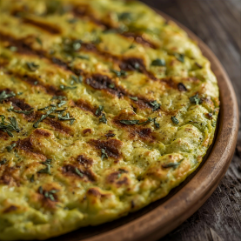***Serves: 2*

*Prep: 10 mins*

*Cook: 25 mins*

1 tbsp. olive oil

1 sweet potato, peeled, chopped

1 small onion, chopped

½ small courgette ( zucchini) thinly sliced

6 eggs

*Heat oil in a non-stick pan and sear the potato and onion over medium-high heat, for about 4 minutes. Next, add the courgette ( zucchini) and sauté for another 4 minutes.*

*In a bowl, whisk eggs and season with salt and pepper. Transfer the vegetables from the pan into the bowl and mix well.*

*Using the same pan, add the egg mixture on low heat and make sure everything is evenly distributed. After about 3 minutes, run a spatula through the outer edges of the tortilla to make sure it does not stick to the pan.*

*After 8-10 minutes, flip the tortilla (this might take more or less, depending on heat, size and pan), using a plate over the pan. Slide the uncooked part back into the pan.*

*After another 5-6 minutes, the tortilla should be cooked. Remove from heat and serve.*

*Nutrition per serving:*

*377 kcal*

*22g Fats*

*22g Carbs*

*21g Protein*

**OMELETTE WRAPS**

*Serves: 4*

*Prep: 15 mins*

*Cook: 10 mins*

7 oz. (200g) cottage cheese

4 handfuls watercress

1 lemon, peel only

6 eggs

¼ cup (60ml) milk of your choice

1 tsp. mixed herbs

4 tsp. coconut oil

3.5 oz. (100g) smoked salmon, chopped

*Place the cottage cheese, watercress and lemon peel in a high bowl and puree with the hand blender (or food processor) until smooth paste forms.*

*Beat the eggs with the milk and herbs in a separate bowl.*

*Heat 1 tsp. of oil in the medium size frying pan and fry* ¼ *of the egg over medium heat for 2 minutes until the egg solidifies, then turn around. Bake the other side for ½ minute.*

*Remove the omelette from the pan and set aside. Fry the other omelettes with the rest of the oil.*

*To serve, spread the cottage cheese paste over the omelette and top with smoked salmon. Roll up the omelette as a wrap and cut in half.*

*Nutrition per serving:*

*237 kcal*

*15g Fats*

*3g Carbs*

*20g Protein*

**COTTAGE CHEESE PANCAKES**

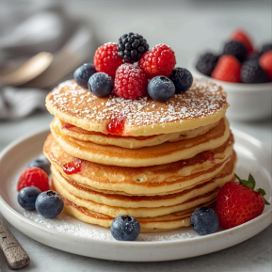

*Serves: 4*

*Prep: 10 mins*

*Cook: 10 mins*

1 heaped cup (250g) cottage cheese

3 eggs

1 tsp. of vanilla extract

1 tbsp. of honey or stevia or sugar free maple syrup

3 heaped tbsp. flour (regular or gluten-free

Desiccated coconut for sprinkling.

*Place the cottage cheese into a bowl, add egg yolks (keep the whites separate) and crush everything with a fork. Add in the flour, and mix thoroughly.*

*Whisk the egg whites into a stiff foam and add to the cheese mixture. Gently combine the ingredients.*

*Heat a dry, non-stick pan and fry the pancakes (about 2 tbsp. of batter per pancake) in batches, for about 3 minutes, until the bottom is slightly browned. Turn and cook for another 2 minutes.*

***Suggested serving:*** *Greek yogurt, honey, and berries, top with coconut flakes.*

*Nutrition per serving:*

*162 kcal*

*4g Fats*

*18g Carbs*

*12g Protein*

**GLUTEN FREE BLUEBERRY PANCAKES**

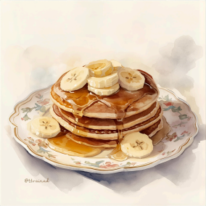

*Serves: 1*

*Prep: 5 mins*

*Cook: 10 mins*

4 egg whites

1 scoop (25g) of vanilla whey powder

½ banana, mashed

almond milk, if needed

¼ cup (25g) fresh or frozen blueberries

½ tsp. coconut oil

*Whisk together the egg whites and protein powder.*

*Stir in the mashed banana and add the blueberries. If the pancake mixture seems too thick, add a splash of almond milk to thin it.*

*Heat the coconut oil in a pan to low-medium. Pour in the pancake mixture and cook until little bubbles form (about 5 minutes).*

*Make sure the pancake has set enough before you try flipping it, then flip over. Cook the pancake for another 2-3 minutes.*

*You can also make 3 small pancakes instead of 1 large.*

*Serve with your favourite toppings.*

*Nutrition per serving:*

*257 kcal*

*5g Fats*

*18g Carbs*

*36g Protein*

**SMOOTHIES**

Smoothies are a wonderful choice when you’re short on time or simply seeking something light, refreshing, and energizing. Whether sipped on the go or savoured as a wholesome dessert, they offer a delicious way to nourish your body and uplift your day.

Beyond convenience, smoothies are packed with health benefits. When made with whole fruits, vegetables, nuts, seeds, and unsweetened liquids, they deliver a powerful blend of vitamins, minerals, antioxidants, and fibre. These nutrients support digestion, boost immunity, stabilize blood sugar, and provide sustained energy— especially helpful for those managing diabetes or seeking gentle nourishment.

Smoothies can also be tailored to meet specific needs:

**For energy:** Add oats, bananas, or nut butters.

**For blood sugar balance:** Include fiber-rich greens, chia seeds, or cinnamon.

**For hydration and skin health:** Blend in cucumber, berries, or coconut water.

**For fullness and satiety:** Use protein-rich ingredients like Greek yogurt or plant-based protein powders.

Each blend becomes a quiet act of self-care—a way to honour your body’s needs while embracing simplicity and grace. In this book, you’ll find smoothie recipes that are not only nutritious and diabetic-friendly, but also comforting and easy to prepare. They’re perfect for busy mornings, gentle resets, or moments when you simply need a sip of something good.

**SMOOTHIE BOWL**

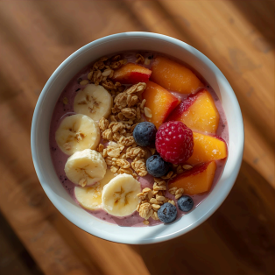

While this dish is typically enjoyed as a sit-down meal, it can easily be packed into a mason jar or food container and enjoyed once you reach your destination.

*Serves: 2*

*Prep: 10 mins*

*Cook: 0 mins*

2 medium peaches, chopped, frozen

1 medium banana, sliced, frozen

¾ cup (190g) natural yogurt

1 scoop (25g) vanilla protein powder (optional) or

1 teaspoon smooth natural nut butter

***Optional toppings:***

fresh berries

Goji berries

walnuts

chia seeds

muesli

*Place all ingredients in a high-speed blender and blitz until smooth.*

*Divide between 2 bowls, add your favourite toppings and serve straight away.*

*Nutrition per serving:*

*252 kcal*

*5g Fats*

*36g Carbs*

*18g Protein*

**VANILLA COFFEE SMOOTHIE**

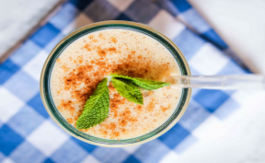

*Serves: 2*

*Prep: 10 mins*

*Cook: 0 mins*

¼ cup (60ml) espresso

1 ⅔ cup (400ml) almond milk

2 scoops vanilla whey powder or natural nut butter or Greek yogurt. 2 tsp. cinnamon

2 tbsp. flax seeds

handful ice

*Please all in gradients in a high-speed blender and mix until smooth. Serve cold in a glass.*

*Nutrition per serving:*

*174 kcal*

*6g Fats*

*4g Carbs*

*26g Protein*

**BLUEBERRY SMOOTHIE**

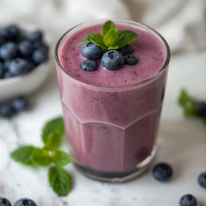

*Serves: 1*

*Prep: 5 mins*

*Cook: 0 mins*

½ cup (125ml) coconut water or plain water if you don’t like coconut. ½ cup (125ml) diary or plant based milk

1 scoop vanilla whey protein or Greek yogurt or natural nut butter ½ cup (50g) frozen blueberries

1 tsp. ground cinnamon

1 tsp. chia seeds

*Blend all the ingredients in a high-speed blender until smooth and serve.*

*Nutrition per serving:*

*197 kcal*

*4g Fats*

*14g Carbs*

*26g Protein*

**CINNAMON SMOOTHIE**

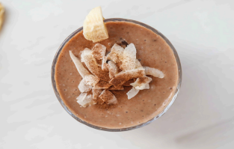

*Serves: 2*

*Prep: 5 mins*

*Cook: 0 mins*

1 banana

2 scoops (50g) vanilla protein powder or Greek yogurt or natural nut butter. 1 tsp. cinnamon

1 cup (240ml) diary or plant based milk

1 cup of ice cubes

*Nutrition per serving:*

*162 kcal*

*3g Fats*

*15g Carbs*

*22g Protein*

SALADS

Who says salads have to be boring? The salads in this book are anything but ordinary. Each recipe is crafted to be both deeply nourishing and delightfully flavourful—proof that healthy eating can be vibrant, satisfying, and full of joy. Whether you’re preparing a hearty main dish or a colourful side, these salads are designed to flex with your needs. Adjust the portions to suit your appetite or the number of people you’re serving, and you’ll find they fit beautifully into any mealtime rhythm.

From crisp greens and roasted vegetables to protein-rich toppings and zesty dressings, these salads celebrate balance and creativity. They’re ideal for those managing diabetes, seeking lighter meals, or simply wanting to

eat well without sacrificing taste.

**TUNA & BROCCOLI SALAD VINAIGRETTE**

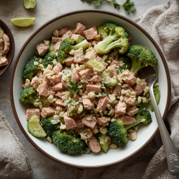

*Serves: 2*

*Prep: 10 mins*

*Cook: 0 mins*

2 big handfuls salad leaves

3 radishes, sliced

½ cup (120g) tuna in water, drained

100g broccoli

2 tsp. Parmesan, grated

***For the dressing:***

2 tbsp. olive oil

3 tbsp. of lemon juice

1 tsp. of honey

salt and pepper

*Divide the salad leaves between two plates. Add the sliced radish and pieces of tuna. Place the broccoli in a pot of boiling water and cook for approx. 5 minutes, then strain and add to the salad.*

*In a bowl, mix all the dressing ingredients and drizzle over the salad. Sprinkle with parmesan cheese and serve*

*Nutrition per serving:*

*328 kcal*

*14g Fats*

*21g Protein*

**WALDORF CHICKEN SALAD**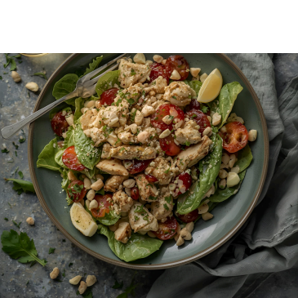

*Serves: 2*

*Prep: 10 mins*

*Cook: 0 mins*

3.5 oz (100g) chicken, cooked, shredded or chopped

3 celery stalks, chopped

1 apple, peeled, deseeded, chopped

¼ cup (40g) raisins

¼ cup (30g) walnuts, chopped

1 tbsp. mayonnaise

1 tbsp. natural low fat yogurt

1 tbsp. lemon juice

3 oz. (90g) mixed salad leaves

*Place the chicken, chopped celery and apple, raisins, and walnuts in a bowl. Add in the mayonnaise, yogurt and lemon juice, season with salt and pepper and mix well.*

*Divide the salad leaves between bowls and top with the filling. Serve with freshly ground black pepper.*

*Nutrition per serving:*

*354 kcal*

*16g Fats*

*33g Carbs*

*20g Protein*

**TUNA & QUINOA SALAD**

**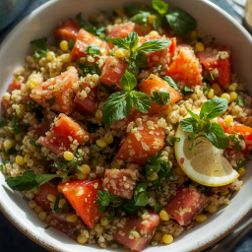***Serves: 2*

*Prep: 10 mins*

*Cook: 10 mins*

1 cup (185g) cooked quinoa

¼ cup (50g) chickpeas, rinsed and drained ½ cucumber, chopped

1 tbsp. crumbled feta cheese

10 cherry tomatoes, halved

2 cans tuna (7oz./200g drained)

***For the dressing:***

1 tbsp. olive oil

2 tsp. red wine vinegar

1 tsp. fresh lemon juice

1 tsp. Dijon mustard

salt and pepper, to taste

*Nutrition per serving:*

*399 kcal*

*11g Fats*

*41g Carbs*

*37g Protein*

**SALMON & COUSCOUS SALAD** 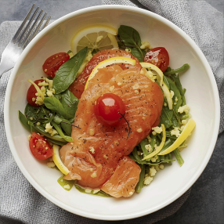

*Serves: 2*

*Prep: 10 mins*

*Cook: 12 mins*

2x 4 oz. (115g) pieces of salmon

2 tsp. olive oil

2 tsp. lemon juice

sea salt and pepper

***For the salad:***

2 cups (150g) iceberg lettuce, chopped 1 cup (157g) couscous, cooked

½ red onion, chopped

10 cherry tomatoes, chopped

2 tbsp. feta cheese

***For the dressing:***

1 tbsp. olive oil

1 tbsp. fresh lemon juice

½ tsp. Dijon mustard

½ tsp. maple syrup or honey (optional)

sea salt and pepper, to taste

*Nutrition per serving:*

*516 kcal*

*29g Fats*

*29g Carbs*

*36g Protein*

**COD & BULGUR SALAD**

*****Serves: 2*

*Prep: 5 + 30 mins*

*Cook: 15-25 mins*

10 oz. (300g) cod fillets

1 tbsp. lemon juice

2 cloves garlic, crushed

½ tsp. turmeric

½ tsp. paprika

½ tsp. cumin

pinch of saffron

2 tbsp. olive oil

scant ½ cup (100g) of bulgur

1 tomato, chopped

¼ onion, chopped

3 sprigs of parsley, chopped

lemon wedges, to serve

Optional; add olives

*Nutrition per serving:*

*447 kcal*

*18g Fats*

*42g Carbs*

*34g Protein*

**CUCUMBER, AVOCADO & CHICKEN SALAD**



*Serves: 4*

*Prep: 10 mins*

*Cook: 15 mins*

***For the salad:***

½ head iceberg lettuce, shredded

a dozen basil leaves, torn

1 avocado

2 tsp. lemon juice

½ cucumber, peeled

¼ cup (25g) walnuts

***For the chicken:***

2 chicken breast fillets (around 150g each)

1 tbsp. olive oil

1 tbsp. mustard

1 tbsp. honey

***For the sauce:***

3 tbsp. yogurt

1 tbsp. mayo

1 garlic clove, minced

*Place the iceberg lettuce into a large bowl. Add torn basil leaves and mix. Divide between 2 serving bowls.*

*Season the chicken fillets with salt and rub with olive oil. Heat a dry pan and fry the chicken for 5 minutes on each side.*

*In the meantime, mix the mustard and honey. Grease the top of the fillets with half the sauce, then turn and cook for another 1.5 minutes. Repeat on the other side. Once cooked, cool slightly and chop.*

*Cut the avocado flesh into cubes, and drizzle with lemon juice. Peel and slice the cucumber. Prepare the garlic sauce by mixing all the sauce ingredients — season with salt & pepper.*

*Top salads with the chopped chicken, avocado, cucumber, and walnuts. Pour over the garlic sauce, and serve.*

*Nutrition per serving:*

*304 kcal*

*20g Fats*

*12g Carbs*

*21g Protein*

**PEAR, CURED HAM & WALNUT SALAD**



*Serves: 2*

*Prep: 15 mins*

*Cook: 0 mins*

bag of rocket

1 ripe pear, sliced

3 oz. (100g) blue cheese, cubed

4 slices cured ham, cut into strips

¼ cup (30g) walnuts, chopped

***Dressing:***

1 tbsp. olive oil

2 tsp. lemon juice

1 tbsp. maple syrup

*Nutrition per serving:*

*466 kcal*

*35g Fats*

*16g Carbs*

*22g Protein*

**CUCUMBER SALAD WITH SALMON **

*Serves: 2*

*Prep: 10 mins*

*Cook: 0 mins*

1 red bell pepper, chopped

1 cucumber, crushed, chopped

1 garlic clove, sliced

fresh coriander, chopped

6 oz. (180g) hot smoked salmon fillets

***For the dressing:***

1 lime, juiced

1 tbsp. fish sauce

1 tbsp. rice wine vinegar

1 tbsp. sesame oil

1 tbsp. black sesame seeds

*Roughly chop the red bell pepper and place in a bowl. Using a meat mallet or a rolling pin, smash the cucumber, then slice into bite-size pieces and transfer into the bowl. Add the sliced garlic and chopped coriander.*

*Mix all the dressing ingredients and drizzle over the cucumber. Mix well and divide between 2 plates.*

*To serve, break the salmon up into pieces and top the cucumber salad — season with freshly ground black pepper.*

*Nutrition per serving:*

*323 kcal*

*23g Fats*

*10g Carbs*

*23g Protein*

**HEALTHY CORONATION CHICKEN SALAD**



*Serves: 2*

*Prep: 10 mins*

*Cook: 0 mins*

1 tbsp. light mayonnaise

2 tbsp. Greek yogurt (0% fat)

1 tsp. curry powder (or more, to taste)

5 oz. (150g) cold cooked chicken, chopped (leftover roast chicken is perfect) 1 celery stick, chopped

1 small onion sliced

Options: feel free to add veggies of your choice.

*Mix the mayonnaise, yogurt, and curry powder. If needed, add a splash of water to thin the sauce to the consistency you like.*

*Stir in the chicken, celery and season to taste with salt and pepper.*

*Serve with a side salad or as a sandwich filling – depending on your dietary needs.. Nutrition per serving:*

*217 kcal*

*8g Fats*

*10g Carbs*

*25g Protein*

**TUNA VEGETABLE SALAD**



*Serves: 4*

*Prep: 10 mins*

*Cook: 10 mins*

1 lemon

¾ cup (160g) tuna pieces in olive oil

½ cup (15g) fresh mint

1 garlic clove, crushed

Cherry Tomatoes (optional)

*Clean the lemon, grate the skin and squeeze out the juice. Drain the tuna, but save the oil for later.*

*Remove the leaves from the sprigs of mint and place in a high cup with the lemon zest, lemon juice, and tuna oil. Add in the garlic and blend until smooth. Season with salt and pepper.*

*If you want to turn this into a meal.*

*Cut the zucchinis (courgette) into slices and sprinkle with salt and pepper. Heat the grill pan and grill the zucchini for 6 minutes, turning halfway. Then cook the asparagus for 4 minutes, turning halfway.*

*Place the vegetables in a bowl and add in the marinade. Mix gently until covered. To serve, divide veg and tuna between plates and top with chopped nuts or mixed seeds.*

*Nutrition per serving:*

*320 kcal*

*24g Fats*

*13g Carbs*

*12g Protein*

**TURKEY SALAD**



*Serves: 5*

*Prep: 25 mins*

*Cook: 0 mins*

1lb. (450g) cooked turkey breast, sliced 1 cup (70g) white cabbage, shredded 1 cup (70g) red cabbage, shredded 1 red bell pepper, finely sliced

1 large carrot, grated

6 radishes, finely sliced

1 cup (100g) bean sprouts 3 green onions, finely sliced 4 tbsp. coriander, chopped 3 tbsp. toasted sesame seeds ⅓ cup (30g) almonds, chopped

***For the dressing:***

¼ cup (60ml) tahini

¼ cup (60ml) water

¼ cup (60ml) lemon juice 1 garlic clove, minced

1 tbsp. honey

*Nutrition per serving:*

*348 kcal*

*18g Fats*

*15g Carbs*

*32g Protein*

Baked Chicken Salad



*Serves: 4*

*Prep: 10 mins*

*Cook: 30 mins*

2 lemons

1 ½ tbsp. oregano

1 ½ tbsp. olive oil

2 tsp. minced garlic

4 skinless, boneless chicken breasts (around 5 oz. (150g) each)

8 oz. (220g) asparagus

8 Spring (green) onions, trimmed

1 tsp. coconut oil

1 ½ tbsp. white wine vinegar

1 packet 4 oz. (120g) rocket

*Heat oven to 400°F (200°C).*

*Grate lemon rinds to equal 2 teaspoons, then halve the lemons and set aside. Combine lemon peel, oregano, oil, and garlic in a large bowl. Add chicken, season with salt and pepper and toss to cover.*

*Place the chicken and halved lemons on a baking tray inside the heated oven and bake for 20-25 minutes, until the chicken is cooked through and browned. Wait until slightly cooled then chop the chicken.*

*Heat the coconut oil in a small pan over medium heat and cook the asparagus and green onions for 3 to 4 minutes or until tender, turning occasionally. Cut asparagus and green onions into 2-inch pieces.*

*Divide the rocket over plates and top with asparagus and green onions. Drizzle with white wine vinegar and season with salt and pepper. Serve with chicken and lemon halves.*

*Nutrition per serving:*

*242 kcal*

*8g Fats*

*2g Carbs*

*38g Protein*

**WARM SALMON & QUINOA SALAD**



*Serves: 4*

*Prep: 5 mins*

*Cook: 20 mins*

1 red pepper

1 tbsp. olive oil

4 wild salmon fillets

1 tsp. spices for salmon

1 ⅓ cup (200g) sugar snaps

4 cups boiling water (1l)

1 ⅓ cup (250g) cooked quinoa

2 handfuls fresh parsley

2 tbsp. fresh chives

*Preheat the oven to 400°F (200°C).*

*In the meantime, cut the peppers into strips. Heat the oil in a pan on medium heat and stir fry the pepper for 5 minutes.*

*Place the salmon on a tray covered with baking paper, season with spices and cook in the oven for 10 minutes.*

*Place sugar snaps in a colander and pour over the boiling water. Then add the sugar snaps and quinoa to the peppers and heat up for 4 minutes on medium heat.*

*Chop parsley and chives and mix into the quinoa. Serve as a side with the salmon.*

**MAIN MEALS**

**Nourishment with Purpose**

Main meals are more than just fuel—they’re moments of restoration, rhythm, and grace. For those managing diabetes or simply seeking a healthier lifestyle, what we place on our plate can shape not only our physical well being but our emotional and spiritual strength.

In this section, you’ll find recipes that are hearty yet healing, flavourful yet balanced. Each dish is crafted to support blood sugar stability, reduce inflammation, and promote fullness without heaviness. You’ll see ingredients chosen for their nutritional integrity—lean proteins, fibre-rich vegetables, whole grains, and healthy fats—all working together to nourish the body and honour the journey toward wellness.

These meals are designed to be:

**Quick and practical**—most ready in under 30 minutes

**Diabetic-friendly**—low in added sugars and refined carbs

**Flexible**—easy to scale for solo servings or family gatherings

**Comforting**—because healthy food should still feel like home

Whether you’re cooking for yourself or preparing meals for loved ones, let each recipe be a quiet act of care—a way to say, “I choose life, balance, and joy.” Let your meals be a reflection of grace—simple, nourishing, and full of intention.

*“So whether you eat or drink or whatever you do, do it all for the glory of God.”* 1 Corinthians 10:31 **SESAME & GINGER BEEF COURGETTE NOODLES**

Courgette (Zucchini) are a great alternative to pasta, which will help you to maintain your blood sugar. Even if you are not a fan of courgette I am sure you will like this alternative as it doesn’t require any cooking. The heat from the cooked beef will ensure you are not eating a cold meal.



*Serves: 4*

*Prep: 5 mins*

*Cook: 12 mins*

¼ cup (60ml) reduced sodium soy sauce

1 tbsp. xylitol (or other sweetener)

2 tbsp. rice wine vinegar

1 lb. (450g) lean minced beef, 5% fat

2 tbsp. sesame oil

1 tbsp. fresh ginger, grated

3 cloves garlic, minced

2 medium courgette (zucchinis), spiralised

**Alternative:** you can also use minced pork, turkey or chicken if you are cutting down on beef. *Mix the soy sauce, rice wine vinegar and sweetener in a small bowl and set aside.*

*Heat a dry non-stick pan over medium heat, add the beef and cook for 7-10 minutes, until cooked through.*

*Move the beef to one side of the pan, then add the sesame oil, ginger and garlic. Cook for 1 minute. Add the already prepared sauce and toss the beef to coat. Cook for 1 minute mixing everything.*

*Slightly heat the spiralised courgette ( zucchinis) with the beef (if eating straight away), or divide zucchini and beef into containers. Heat in the microwave or pan when needed*

**Nutrition per serving:**

*242 kcal*

*12g Fats*

*10g Carbs*

*25g Protein*

**BAKED SALMON QUINOA COURGETTE NOODLES **

*Serves: 2*

*Prep: 10+1h chill*

*Cook: 15 mins*

2 salmon fillets (4.4 oz. /125g each)

3.5 oz. (100g) quinoa, cooked

1 courgette ( zucchini)

½ tbsp. olive oil

1 garlic clove, crushed

2.5 oz. (70g) sundried tomatoes, rinsed, chopped

***Salmon marinade:***

2 tbsp. tamari

½ tbsp. olive oil

½ tsp. sweet paprika

½ tsp. hot paprika

1 tbsp. rice vinegar

1 tsp. honey

1 tbsp. black sesame seeds

chili flakes, to taste

*Mix together the ingredients of the marinade and cover the salmon to marinate for about 1 hour. While the salmon is marinating, cook the quinoa and spiralise the courgette ( zucchini)*

*Heat the oil in the pan, add the crushed garlic and fry for 1-2 minutes. Add in the noodles and stir occasionally until it softens (about 3-4 minutes). Towards the end add the chopped tomatoes, and season with salt and pepper, to taste.*

*Heat the oven to 480°F (250°C) and place the salmon on a baking tray or casserole dish. Bake for about 7 minutes.*

*Remove the salmon from the oven to rest for a moment. In the meantime, pour in the salmon juices into the quinoa, and mix well.*

*Divide the quinoa and noodles between two plates, then place the salmon on top. Sprinkle with chili flakes to serve.*

*Nutrition per serving:*

*487 kcal*

*28g Fats*

*19g Carbs*

*38g Protein*

**CHICKEN FAJITAS**

One of the beautiful aspects of this dish is its flexibility—you can easily swap traditional tortillas for crisp lettuce leaves, making it a lighter, blood-sugar-friendly option. If your type of diabetes calls for avoiding bread, this simple substitution allows you to enjoy the flavours without compromise.



*Serves: 8*

*Prep: 10 mins*

*Cook: 3-4hrs*

2 lbs. (900g) chicken breasts or thighs

4 bell peppers, sliced

1 red onion, sliced

2 tbsp. honey

1 tbsp. olive oil

1 lime, juice

1 tbsp. chili powder

1 tbsp. cumin

1 tbsp. paprika

1 tsp. salt

1 tsp. onion powder

1 tsp. garlic powder

1 cup chopped tomatoes

*Place half of the sliced peppers and onion in the slow cooker. Layer the chicken and coat with honey, olive oil, lime juice, all the seasonings and chopped tomatoes.*

*Lastly, add the remaining peppers and onions and cook for 4 hours on high.*

*Remove the chicken and shred it with a fork, then return it in in the slow-cooker. Mix well and cook for another 10 mins. on low.*

*Assemble fajitas or lettuce and enjoy.*

***Serving suggestions (not included in nutrition info) :*** *gluten free or whole wheat tortillas, cream, Greek yogurt, guacamole.*

*Nutrition per serving:*

*183 kcal*

*3g Fats*

*12g Carbs*

*28g Protein*

**BEEF & GREEN BEANS PASTA IN SOY SAUCE **

*Serves: 2*

*Prep: 10 mins*

*Cook: 15 mins*

4 oz. (120g) whole-wheat pasta

10 oz. (300g) beef steak

4 spring onions

2 cloves garlic

1 tbsp. coconut oil

2 tbsp. soy sauce

⅓ cup (80ml) beef stock

100g green beans, frozen

*Cook the pasta according to instructions on the packaging.*

*Cut the beef into thin slices.*

*Slice the spring onions. Peel and slice the garlic.*

*Heat the oil in a large pan over medium-high heat and cook the beef for about 3 minutes, then transfer onto a plate and drizzle with soy sauce.*

*Add the garlic and spring onions to the same pan and cook for about 3 minutes, until spring onions start to soften.*

*Return the beef and soy sauce into the pan and add the hot stock and frozen beans. Cook for another 2-3 minutes, then add the cooked pasta. Stir occasionally for about 2 minutes.*

*Nutrition per serving:*

*491 kcal*

*12g Fats*

*53g Carbs*

*44g Protein*

**SALMON TERIYAKI WITH GREEN BEANS & SWEETCORN RICE**



*Serves: 4*

*Prep: 10 + 1 h*

*Cook: 15 mins*

4 salmon fillets (5 oz./150g each)

5 oz. (150g) green beans, frozen

1 cup (150g) sweetcorn (optional)

3.5 oz. (100g) brown rice

2 tbsp. sesame seeds

1 tbsp. sesame oil

***For the sauce:***

8 tbsp. soy sauce

3 tbsp. maple syrup

1 tbsp. lime juice

4 tbsp. grated ginger

2 garlic cloves, grated

*Make the marinade by mixing all the sauce ingredients together. Season with salt and pepper. Cut the skin off the salmon then rinse, dry and marinate in the prepared sauce for 1 hour.*

*In the meantime, cook the rice according to the instructions on the packaging. Add the green beans to the cooking rice 4 minutes before it is cooked, then drain. Next, add the sweetcorn and mix well.*

*Preheat the oven to 450°F (230°C). Place the salmon into an oven safe dish, leaving the marinade aside. Bake for 8-10 minutes. 3 minutes before the end of baking, sprinkle with sesame seeds.*

*Transfer the marinade into a small saucepan and heat until it thickens. Mix in the sesame oil, take off the heat and set aside.*

*To serve, divide the rice and salmon between plates, then drizzle with the teriyaki sauce.*

*Nutrition per serving:*

*507 kcal*

*19g Fats*

*40g Carbs*

*45g Protein*

**PESTO PASTAWITH TUNA & ALMONDS**



*Serves: 4*

*Prep: 10 mins*

*Cook: 10 mins*

10.5 oz. (300g) gluten-free pasta of your choice

14 oz. (400g) green beans

8.4 oz. (240g) tuna in water, drained (2 tins)

1 oz. (30g) roasted almonds, chopped

4.5 oz. (130g) green pesto

*Cook the pasta according to the instructions on the packet.*

*In the meantime, halve the green beans and cook in boiling water for about 5 minutes, then drain.*

*Meanwhile, let the tuna drain and chop the almonds coarsely.*

*Drain the pasta and mix with the pesto and green beans. Divide the pasta between bowls and scatter the tuna over it. Garnish with almonds to serve. Season with pepper.*

*Alternative: zoodles in place of pasta.*

*Nutrition per serving:*

*512 kcal*

*16g Fats*

*69g Carbs*

*24g Protein*

**QUICK BEEF CHOW MEIN**



*Serves: 4*

*Prep: 10 mins*

*Cook: 10 mins*

5.5 oz. (160g) egg noodles

7 oz. (200g) beef tenderloin

1 tbsp. sesame oil

1 clove garlic, minced

1 tbsp. ginger, grated

½ leek, sliced (mostly white parts)

1 red bell pepper, sliced

3 mushrooms, sliced

a pinch of ground white pepper

a pinch of sugar

3 tbsp. soy sauce + 2 tbsp. water

2 tbsp. spring onions, chopped

*Prepare the noodles according to instructions on the packet.*

*Cut the beef into thin strips.*

*Heat the sesame oil in a wok or a large frying pan. Add the garlic and ginger and fry for about a minute. Add the beef and cook for another 2 minutes. Next, add the leeks, pepper and mushrooms and fry for about 5 minutes.*

*Finally, add the cooked noodles, season with pepper and a pinch of sugar. Pour in the soy sauce and water, then stir and fry for another 2 minutes.*

*To serve, divide onto serving dishes and garnish with chopped spring onions.*

***Options:*** *replace beef with sliced chicken, pork or tofu.*

*Zoodles in place of egg noodles.*

**CHILLI & SWEET POTATO CHIPS**



*Serves: 4*

*Prep: 10 mins*

*Cook: 40 mins*

***For the potatoes:***

3 medium sweet potatoes

2 tsp. garlic powder

1 tsp. onion powder

2 tbsp. buckwheat flour

1 tbsp. olive oil

salt and pepper

***For the simple chili:***

1 lb. (450g) lean ground beef

1 tbsp. chili flakes

1 can chopped tomatoes (14oz./400g)

6 fl. oz. (170ml) water

***For the garnish:***

2 tbsp. coriander, chopped

1 avocado, mashed

*Nutrition per serving:*

*382 kcal*

*16g Fats*

*33g Carbs*

*29g Protein*

**DESSERTS/HEALTHY TREATS**

The desserts in this book may be simple, but they’re full of flavour and incredibly easy to put together—even if baking isn’t your thing. I’ve carefully chosen ingredients that are suitable for those managing diabetes, when enjoyed occasionally and in moderation. And while I say this with care, not criticism, please be mindful of your recommended limits to ensure these sweet moments remain a nourishing part of your journey.

**CHERRY SORBET**



*Serves: 4*

*Prep: 10 mins*

*Freezing time: 1 hr.*

1 ¾ cups (400g) frozen pitted cherries

2 tbsp. honey

1 tbsp. lemon juice

4 tbsp. vanilla or any flavoured yogurt of your choice

4 tbsp. water

mint leaves, to serve

*Blitz the frozen cherries in a food processor or high-speed blender with the honey, 1 tbsp. of lemon juice, 4 tbsp. of yogurt and 4 tbsp. of water until smooth.*

*Spoon into a freezer-proof container then freeze for 1 hour.*

*Scoop out the sorbet into serving glasses, top with mint and serve immediately. The ingredients will make approx. 8 scoops of sorbet (2 per serving).*

*Nutrition per serving:*

*109 kcal*

*1g Fats*

*24g Carbs*

*2g Protein*

**2 WAYS FRUIT BOWLS**



*Serves: 2*

*Prep: 10 mins*

*Cook: 0 mins*

***For the mango bowl:***

7 oz. (200g) natural quark or creamy natural yogurt

¼ mango, chopped

1 tbsp. granola

***For the strawberry bowl:***

7 oz. (200g) natural quark or creamy natural yogurt

5 strawberries, halved

½ banana, sliced (0ptional)

1 tbsp. coconut chips

*Spoon the quark into serving bowls or glasses. Garnish with the toppings and serve.* Options: you can add omit or add more toppings of your choice.

*Nutrition per serving:*

*250 kcal*

*4g Fats*

*30g Carbs*

*25g Protein*

**MATCHA CHIA PUDDING**



*Serves: 2*

*Prep: overnight*

*Cook: 0 mins*

¼ cup (30g) chia seeds

1 ½ cup almond milk

2 tsp. maple syrup

3 tbsp. (40g) protein powder of your choice

1 tsp. matcha

1 cup (100g) fresh or frozen berries, to serve

*Mix the chia seeds and almond milk and place in the fridge. After an hour, mix again and place back in the refrigerator to chill overnight.*

*The next morning, mix in the maple syrup, protein powder, and matcha.*

*Divide between two bowls and serve with berries.*

***Option****: add smooth natural butter if you don’t like protein powder.*

*Nutrition per serving:*

*275 kcal*

*9g Fats*

*19g Carbs*

*23g Protein*

**LOW FAT BANANA & STRAWBERRY CAKE**

This gentle cake is more than a treat—it’s a quiet celebration of simplicity and grace. Ripe bananas lend natural sweetness, while fresh strawberries crown each slice with joyful color. It’s low in fat, but rich in comfort. As you prepare and share this recipe, may it remind you that even in seasons of restraint, there is beauty to be found in what’s wholesome, humble, and lovingly made.

"Taste and see that the Lord is good; blessed is the one who takes refuge in Him." — Psalm 34:8



*Serves: 16*

*Prep: 10 mins*

*Cook: 60 mins*

4 small ripe bananas

1 cup (130g) wheat flour

½ cup (60g) buckwheat flour

¼ cup (60ml) coconut oil

2 tbsp. stevia/xylitol or liquid sweetner

1 egg

1 tsp. baking powder

10 strawberries, halved

*Pre-heat oven to 350°F (180°C).*

*Peel the bananas and place them in a food processor or high-speed blender. Blitz until smooth.*

*Add in the egg, oil and xylitol, then mix again. Next, add in the flours and baking powder, and blitz until a smooth batter is formed.*

*Transfer the batter into a greased or silicon cake tray. Place the halved strawberries on top and bake for around 60 minutes, until the cake is golden brown and cooked through.*

*Allow the cake to cool, cut into slices, serve topped with Greek yogurt or quark. Tip: you can slice and freezer the cake.. Once thawed, it can be heated in a microwave before serving.*

*Nutrition per serving:*

*104 kcal*

*5g Fats*

*16g Carbs*

*2g Protein*

**Conclusion**

Every recipe in this collection was created to support your health journey with joy, simplicity, and spiritual encouragement. These meals are low in sugar but rich in meaning.

You’ll find fruits, whole grains, and gentle sweetness throughout—each chosen to nourish both body and soul. Feel free to adapt ingredients and portions to suit your needs. This isn’t about perfection—it’s about presence, patience, and progress.

Living with diabetes invites us to listen more deeply—to our bodies, our rhythms, and the Spirit’s quiet guidance. This eBook is more than a recipe guide; it’s a companion for the journey. A reminder that nourishment can be sacred, and that healing often begins in the humble act of preparing a meal.

May each dish remind you that you are held, guided, and never alone. That even in seasons of restriction, there is abundance to be found—in flavour, in faith, and in the quiet joy of caring for yourself.

*“I will satisfy the weary soul, and every languishing soul I will replenish.”*— Jeremiah 31:25

*My social media:*

*Tictok – deerocket*

*Instagram - deenutritious*